INDEX
Sr. No. | Practical Name | Page No. | Teacher Sign
1 | Set up environment (Anaconda/Colab), create and run Python scripts in Jupyter Notebook. Print messages, check Python version, and perform basic arithmetic input/output. | 1
2 | Create variables for all Python data types, print their type, perform conversions, and demonstrate arithmetic, comparison, logical, and assignment operators. | 2-4
3 | Write program to calculate travel fare using if/elif and match-case statements with conditions for age and weekend discounts. | 5-6
4 | Develop programs with for and while loops to print tables, sum even numbers, and use break/continue. Create patterns with nested loops. | 7-9
5 | Create functions using math and random modules, implement recursion, and demonstrate lambda with map and filter. | 10-11
6 | Build grocery list manager demonstrating list creation, indexing, slicing, append, extend, insert, index, count, sort, reverse, pop, and nested lists. | 12-13
7 | Create a 2-D list for student marks, compute totals, averages, and transpose the list. | 14-15
8 | Develop text analyzer applying string methods like capitalize, lower, upper, strip, replace, find, index, count, startswith, endswith, split, etc. | 16
9 | Create attendance tracker using sets, tuples, and dictionaries with set operations, tuple immutability, dictionary methods, and date/time functions. | 17-18
10 | Build quiz game using random module, file write/read operations, and file seek for cursor movement. | 19-20
11 | Create classes and inheritance with method overriding, operator overloading, and making classes iterable. | 21-22
Program 1: Set up environment (Anaconda/Colab), create and run Python scripts in Jupyter Notebook. Print messages, check Python version, and perform basic arithmetic input/output.

Objective: The objective of this program is to learn how to set up the Python programming environment, create and run Python scripts, print messages on the screen, check the installed Python version, and perform basic input/output operations including simple arithmetic calculation

Code:

# Displaying welcome message(Printing messages)
print(“Hello World”)
print(“This is my first code”)
# Import the 'sys' module to access system-specific parameters and functions check python version
import sys
print(sys.version)
# printing keyword in python using import func
import keyword
print(keyword.kwlist)
# Taking input from user and performing basic arithmetic input/output.
a=(“enter number 1”)
b=(“enter number 2”)
sum=a+b
prod=a*b
div=a/b
print(sum, prod, div)

Output:
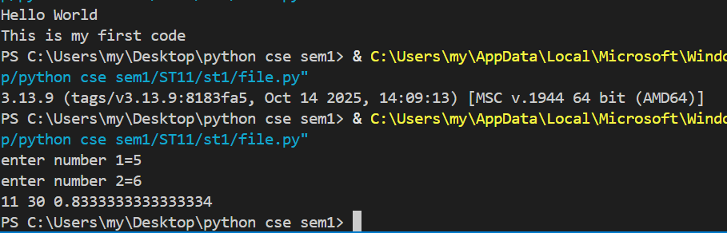

Program 2: Creating variables for all Python data types, print their type, perform conversions, and demonstrate arithmetic, comparison, logical, and assignment operators.

Objective: The objective of this program is to create variables of different Python data types, display their types, perform type conversion, and demonstrate the use of arithmetic, comparison, logical, and assignment operators to understand basic Python operations and data handling.

Code:

# Creating variables for all Python data types and printing their type
a="hello" #string data type a=True #boolean data type
print(type(a)) print(type(a))
a=42 # integer data types a={"Name":"Tanish"} #dict
print(type(a)) print(type(a))
a=3.14 # float data type a=(1,2,3,4,5) #tupple data type
print(type(a)) print(type(a))
a=5+9j #complex data type
print(type(a))
a=[1,2,3,4,5] #list data type
print(type(a))
a={1,2,3,4,5} #set data type
print(type(a))

# TYPE CONVERSIONS between int, float, and str
# int ↔ float
x_int = 10
x_float = float(x_int)
print("int → float:", x_int, "→", x_float)
y_float = 9.99
y_int = int(y_float) # truncates toward 0 (does not round)
print("float → int:", y_float, "→", y_int)
# any → str
pi = 3.14159
pi_str = str(pi)
print("float → str:", pi, "→", pi_str, " (type:", type(pi_str).__name__, ")")
# str → int/float (only works if the string is numeric)
s_num = "123"
print("str → int:", s_num, "→", int(s_num))
print("str → float:", s_num, "→", float(s_num))
# Arithmetic operators
a, b = 15, 4
print("a + b =", a + b) # addition
print("a - b =", a - b) # subtraction
print("a * b =", a * b) # multiplication
print("a / b =", a / b) # true division (float)
print("a // b =", a // b) # floor division (int if both ints)
print("a % b =", a % b) # modulus (remainder)
print("a ** b =", a ** b) # exponentiation
# Comparison operators
x, y = 7, 10
print("x == y:", x == y)
print("x != y:", x != y)
print("x < y:", x < y)
print("x <= y:", x <= y)
print("x > y:", x > y)
print("x >= y:", x >= y)
# Comparisons also work with floats/strings (lexicographic for strings)
print("'apple' < 'banana':", "apple" < "banana")
# Logical operators
t, f = True, False
print("t and f:", t and f)
print("t or f :", t or f)
print("not t :", not t)
# Python returns one of the operands, not strictly True/False, when used with non-bools:
print("5 and 0 →", 5 and 0) # returns 0 (first falsy)
print("0 or 'hi' →", 0 or "hi") # returns 'hi' (first truthy)
#Assignment operators
n=5
print("start n:", n)
n += 3 # n = n + 3
print("n += 3 →", n)
n *= 2 # n = n * 2
print("n *= 2 →", n)
n -= 4 # n = n - 4
print("n -= 4 →", n)
n //= 2 # floor divide
print("n //= 2 →", n)
n %= 3
print("n %= 3 →", n)
n **= 4
print("n **= 4 →", n)

Output:

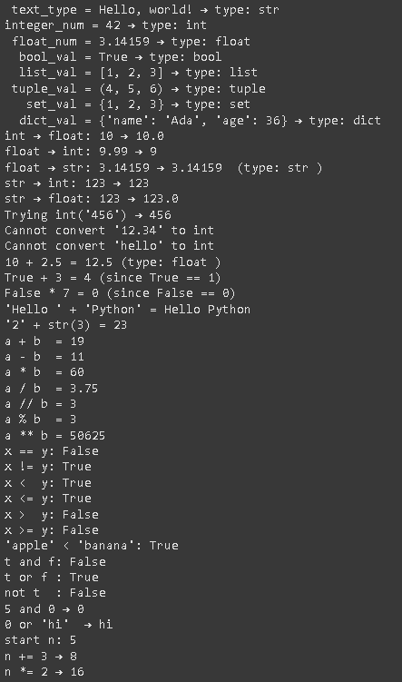

Program 3: Write program to calculate travel fare using if/elif and match case statemerits with conditions for age and weekend discounts.

Objective: The objective of this program is to calculate the travel fare based on user inputs by applying conditions for age-based discounts and weekend discounts. The program demonstrates the use of decision-making statements by implementing both if/elif and match-case structures in Python

Code:

# getting user input
age = int(input("Enter passenger's age: "))
day = input("Enter the day of the week: ")

# Method 1: Using if/elif/else
# Start with the base fare based on age
if age <= 4:
fare = 0.0 # Toddler
elif age < 18:
fare = 5.0 # Child (50% of $10)
elif age < 65:
fare = 10.0 # Adult
else:
fare = 7.50 # Senior (75% of $10)
# Add weekend surcharge if needed
if day == "Saturday" or day == "Sunday":
if fare > 0: # Don't charge toddlers
fare += 2.0
print(“TOTAL FARE=”,fare)

# Method 2: Using match/case
# Match age to get base fare
match age:
case a if a <= 4:
fare = 0.0
case a if a < 18:
fare = 5.0
case a if a < 65:
fare = 10.0
case _:
fare = 7.50

# Match day to add surcharge
match day:
case "Saturday" | "Sunday":
if fare > 0:
fare += 2.0
print(fare)

Output:

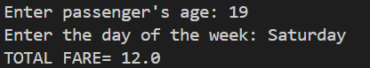

Program 4: Develop programs with for and while loops to print tables sum even numbers, and use break/continue. Create patterns with nested loops.

Objective: The objective of this program is to understand and apply iterative control structures in Python by using for and while loops to print tables, calculate the sum of even numbers, and demonstrate the use of break and continue statements. The program also aims to create various star and number patterns using nested loops.

Code:

#Developing programs with for and while loops to print tables, sum of numbers, even numbers.
# 1. Print a Multiplication Table (Table of 5)
# Using a 'for' loop
for i in range(1, 11): # i will be 1, 2, 3, ..., 10
print(f"5 x {i} = {5 * i}")
# Using a 'while' loop
i = 1 # Start counter at 1
while i <= 10:
print(f"5 x {i} = {5 * i}")
i += 1 # Add 1 to i so the loop eventually stops
# 2. Sum All Even Numbers from 1 to 10
total = 0
for number in range(1, 11): # number will be 1, 2, 3, ..., 10
if number % 2 == 0: # If the number is even...
total += number # ...add it to the total

# The sum of even numbers from 1 to 10 is 2 + 4 + 6 + 8 + 10 = 30
print(f"The sum of even numbers is: {total}")
# 3. Using 'break' and 'continue'
for number in range(1, 11):
# Use 'continue' to skip the number 4
if number == 4:
print("Skipping 4!")
continue # Go to the next loop iteration immediately

# Use 'break' to stop the loop when we find the number 8
if number == 8:
print("Found 8! Stopping the loop.")
break # Exit the loop completely

# This will only print if we didn't continue or break
print(number)

#Printing patterns using loops(Pattern Printing)
# Pattern 1: The Simple Square
rows = 5
for i in range(rows): # Outer loop for the rows (will run 5 times)
for j in range(rows): # Inner loop for the columns (will also run 5 times for each row)
# print an asterisk but don't go to the next line yet
print("* ", end="")

# After the inner loop finishes, print a newline to move to the next row
print()

# Pattern 2: The Right-Angled Triangle
rows = 5
The outer loop i will go from 1 to 5.
for i in range(1, rows + 1):
# The inner loop's range depends on the outer loop's current number (i).
# If i is 1, it prints 1 star. If i is 3, it prints 3 stars.
for j in range(i):
print("* ", end="")

# Move to the next line to start the next row
print()
# Pattern 3: The Pyramid (Isosceles Triangle)
rows = 5
# The outer loop controls the rows.
for i in range(rows):
# 1. Inner loop for the leading spaces
# The number of spaces decreases as we go down the rows.
for j in range(rows - i - 1):
print(" ", end="")

# 2. Inner loop for the asterisks
# The number of asterisks increases by 2 in each row (1, 3, 5, ...).
for k in range(2 * i + 1):
print("*", end="")

# After printing spaces and asterisks, move to the next line.
print()

Output:

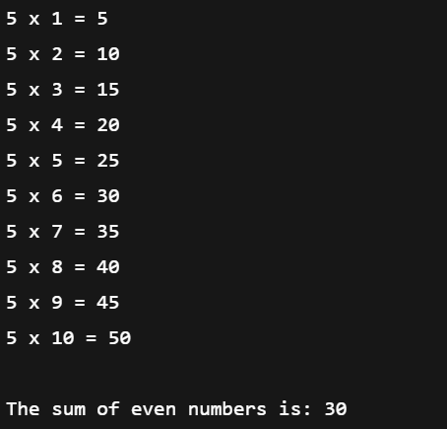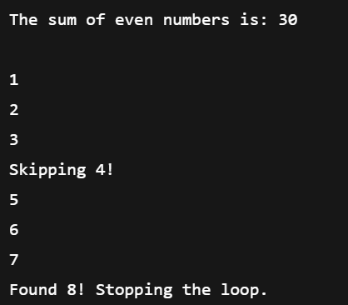
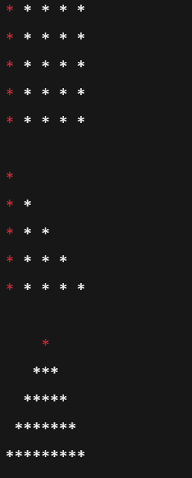

Program 5: Create functions using math and random modules, implement recursion, and demonstrate lambda with map and filter.

Objective of Program: Create a Python notebook that defines:
- functions using the math module (factorial, sqrt, power)
- functions using the random module (random integers, choices)
- a recursive function
- usage of lambda expressions with map() and filter()
- print clear outputs exactly like a lab program

Solution

# 1. Import modules
import math
import random

# Fix seed so output stays EXACT every time
random.seed(10)

num_for_math = int(input("Enter a number for math operations: "))
num_for_recursive = int(input("Enter a number for recursive sum: "))

# 2. Functions using math module
def math_operations(x):
print("\n--- Math Operations ---")
print("Number:", x)
print("Square root:", math.sqrt(x))
print("Square:", math.pow(x, 2))
print("Factorial:", math.factorial(int(x)))

# 3. Functions using random module
def random_examples():
print("\n--- Random Module Output ---")
print("Random integer (1–10):", random.randint(1, 10))
print("Random choice from list:", random.choice([10, 20, 30, 40]))
print("Random float (0–1):", random.random())

# 4. Recursive function
def recursive_sum(n):
if n == 1:
return 1
return n + recursive_sum(n - 1)

# 5. Lambda, map, and filter
nums = [1, 2, 3, 4, 5]

# lambda with map
squares = list(map(lambda x: x * x, nums))

# lambda with filter
evens = list(filter(lambda x: x % 2 == 0, nums))

math_operations(num_for_math)
random_examples()
print("\n--- Recursion ---")
print(f"Recursive sum of {num_for_recursive} =", recursive_sum(num_for_recursive))
print("\n--- Lambda / Map / Filter ---")
print("Original list:", nums)
print("Squares using map+lambda:", squares)
print("Even numbers using filter+lambda:", evens)

OUTPUT

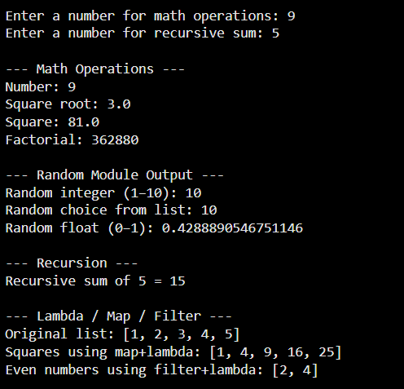
Program 6: Build grocery list manager demonstrating list creation, Indexing, slicing, append, extend insert, index, count, sort, reverse, pop, and rested lists

Objective: To create a simple Grocery List Manager that demonstrates essential Python list operations, including creation, indexing, slicing, adding items (append, extend, insert), searching (index, count), sorting, reversing, removing items (pop), and using nested lists.

Code:

#Building grocery list manager
grocery_list = ["Milk", "Bread", "Eggs"]
while True:
print("List”, grocery_list)
choice = input("1:Add 2:Extend 3:Insert 4:Pop 5:Sort 6:Reverse 7:Find 8:Slice 0:Exit\n> ")

if choice == '1':
grocery_list.append(input("Item: "))
elif choice == '2':
grocery_list.extend(input("Items (space-separated): ").split())
elif choice == '3':
grocery_list.insert(int(input("Pos: ")), input("Item: "))
elif choice == '4':
removed_item = grocery_list.pop(int(input('Pos: ')))
print("Removed:", removed_item)
elif choice == '5':
grocery_list.sort()
elif choice == '6':
grocery_list.reverse()
elif choice == '7':
item = input("Item: ")
if item in grocery_list:
# Use string concatenation and str() to build the output string
print("Index: " + str(grocery_list.index(item)) + ", Count: " + str(grocery_list.count(item)))
else:
print("Not found.")
elif choice == '8':
start, end = int(input("Start: ")), int(input("End: "))
print("Slice:", grocery_list[start:end])
elif choice == '0':
break
else:
print("Invalid choice.")

Output:

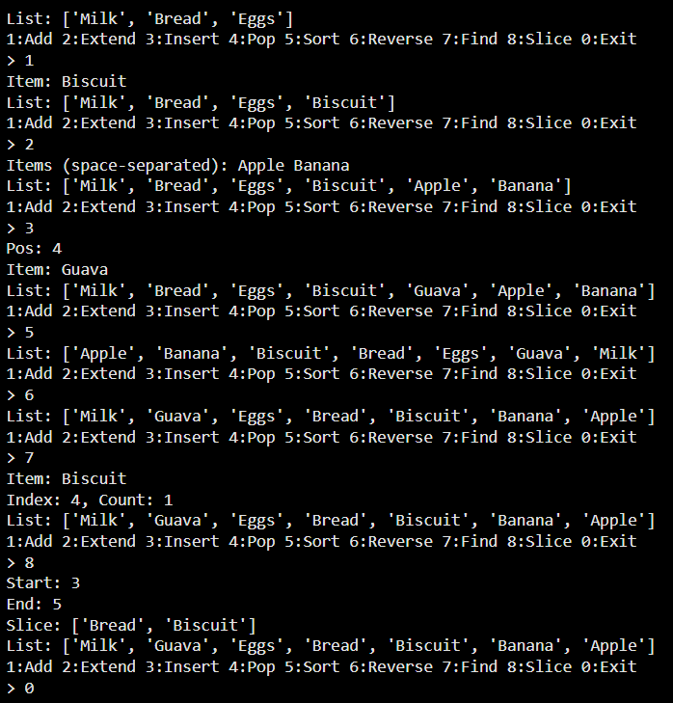

Program 7 : Create a 2-D list for student marks, compute totals, averages, and transpose the list.
Objective of program: Create a Python program that:
- Accepts student marks in a 2-D list (rows = students, columns = subjects).
- Computes the total marks and average marks for each student.
- Computes the transpose of the 2-D list (subjects become rows).
- Displays all results clearly.
Solution:

rows = int(input("Enter number of students: "))

cols = int(input("Enter number of subjects: "))

print("\nEnter marks row-wise:")

marks = []

for i in range(rows):

row = []

for j in range(cols):

value = int(input(f"Student {i+1}, Subject {j+1}: "))

row.append(value)

marks.append(row)

# 1. Total & Average for each student

totals = []

averages = []

for row in marks:

total = sum(row)

avg = total / len(row)

totals.append(total)

averages.append(avg)

# 2. Transpose of 2-D list

transpose = []

for c in range(cols):

column = []

for r in range(rows):

column.append(marks[r][c])

transpose.append(column)

print("\n--- Original 2-D List (Marks) ---")

for row in marks:

print(row)

print("\n--- Total Marks of Each Student ---")

for i, t in enumerate(totals, start=1):

print(f"Student {i}: {t}")

print("\n--- Average Marks of Each Student ---")

for i, a in enumerate(averages, start=1):

print(f"Student {i}: {a}")

print("\n--- Transposed List (Subjects as Rows) ---")

for row in transpose:

print(row)

OUTPUT
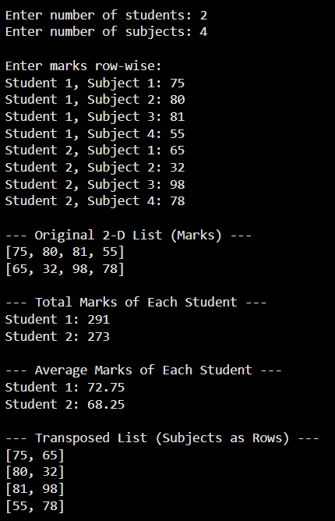
Program 8: Develop text analyzer applying string methods like capitalize, lower, upper, strip, replace, find, index, count, startswith, endswith, split, etc.

Objective of Program: Create a Python program that takes a sentence as input and applies common string methods such as:
capitalize(), lower(), upper(), strip(), replace(), find(), index(), count(), startswith(), endswith(), split() and prints the results.

Solution
# Text Analyzer Using String Methods

text = input("Enter a sentence: ")

print("Original:", text)
print("Capitalized:", text.capitalize())
print("Lowercase:", text.lower())
print("Uppercase:", text.upper())
print("Stripped:", text.strip())
print("Replace 'a' with '@':", text.replace("a", "@"))
print("Find 'is':", text.find("is"))
print("Index of 'is':", text.index("is") if "is" in text else "Not found")
print("Count of 'the':", text.count("the"))
print("Starts with 'The':", text.startswith("The"))
print("Endswith 'end':", text.endswith("end"))
print("Split words:", text.split())

OUTPUT

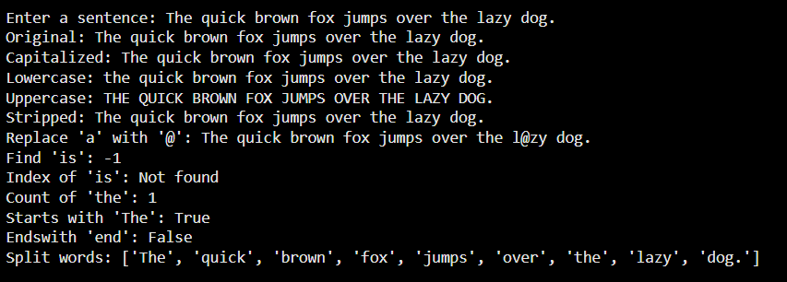

Program 9: Create attendance tracker using sets, tuples, and dictionaries with set operations, tuple immutability, dictionary methods, and date/time functions.

Objective of Program: Create an attendance tracker using sets, tuples, and dictionaries. Use set operations, show tuple immutability, use dictionary methods, and display the current date and time.

Solution

import datetime

# current date and time
now = datetime.datetime.now()
print("Date and Time:", now)

# tuple for class information (immutable)
class_info = ("Class A", "Room 101", "Morning")
print("Class info:", class_info)

# sets for attendance
present = {"John", "Sara", "Amit", "Rita"}
absent = {"Karan", "Meera", "Amit"} # Amit appears in both intentionally

# set operations
print("Present:", present)
print("Absent:", absent)
print("Only present:", present - absent)
print("Only absent:", absent - present)
print("Common names:", present & absent)
print("All students (union):", present | absent)

# dictionary for student status
attendance = {
"John": "Present",
"Sara": "Present",
"Amit": "Present",
"Rita": "Present",
"Karan": "Absent",
"Meera": "Absent"
}

# dictionary methods
print("Keys:", attendance.keys())
print("Values:", attendance.values())
print("Items:", attendance.items())

# update dictionary
attendance["Meera"] = "Present"
print("Updated Meera:", attendance["Meera"])

OUTPUT

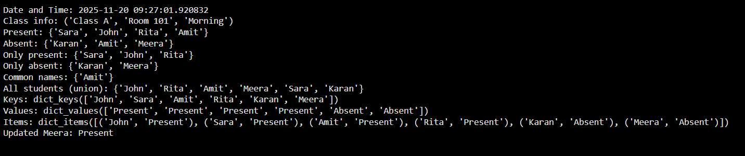

Program 10: Build quiz game using random module, file write/read operations, and file seek for cursor movement.

Objective of Program: Create a Python quiz game that randomly selects a question, stores the player's answer in a file, reads the saved data, and demonstrates file cursor movement using the seek() function.

Solution

import random

# quiz questions stored in a list of tuples

questions = [

("What is the capital of India?", "Delhi"),

("2 + 2 = ?", "4"),

("Color of the sky?", "Blue")

]

# pick a random question

q, ans = random.choice(questions)

# ask the user

print("Question:", q)

user_ans = input("Your answer: ")

# check correct or wrong

if user_ans.strip().lower() == ans.strip().lower():

print("Correct!")

else:

print("Wrong!")

# write result to file

with open("quiz_result.txt", "w") as f:

f.write("Question: " + q + "\n")

f.write("Correct Answer: " + ans + "\n")

f.write("Your Answer: " + user_ans + "\n")

# read file and use seek to move cursor

with open("quiz_result.txt", "r") as f:

print("\nFull File Content:")

print(f.read())

# move cursor back to start

f.seek(0)

print("First 15 characters from file:")

print(f.read(15))

OUTPUT

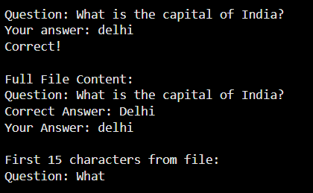

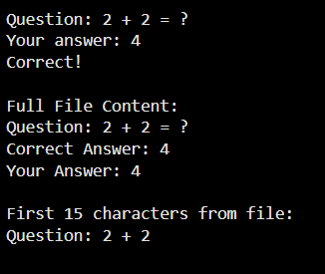

Program 11: Create classes and inheritance with method overriding, operator overloading, and making classes iterable.
Objective of Program: Create classes demonstrating inheritance, method overriding, operator overloading, and iteration. The program defines a base class and a derived class, overrides a method, overloads the + operator to combine marks of two students, and makes the class iterable so marks can be looped through.

Solution
# base class
class Student:
def __init__(self, name):
self.name = name

def show(self):
return "Student Name: " + self.name

# derived class overriding method
class Marks(Student):
def __init__(self, name, marks):
super().__init__(name)
self.marks = marks

def show(self):
return "Student: " + self.name + " | Marks: " + str(self.marks)

# operator overloading: add marks of two students
def __add__(self, other):
return self.marks + other.marks

# making the class iterable
def __iter__(self):
self.index = 0
return self

def __next__(self):
if self.index < len(self.marks):
value = self.marks[self.index]
self.index += 1
return value
else:
raise StopIteration

# create objects
s1 = Marks("Amit", [80, 90, 85])
s2 = Marks("Riya", [70, 75, 88])

# method overriding
print(s1.show())
print(s2.show())

# operator overloading
total = s1 + s2
print("Sum of marks of two students:", total)

# iteration over object
print("Marks of Amit:")
for m in s1:
print(m)

OUTPUT

